Functional | Exp λ_{max} | Cal λ_{max}
B3LYP |  | 315
CAMB3LYP |  | 274
MPW1PW91 |  | 304
ꞷb97XD |  | 266
SUPORTING INFORMATION

Supplementary Table 1. Comparison of different functional for calculations absorption spectra.

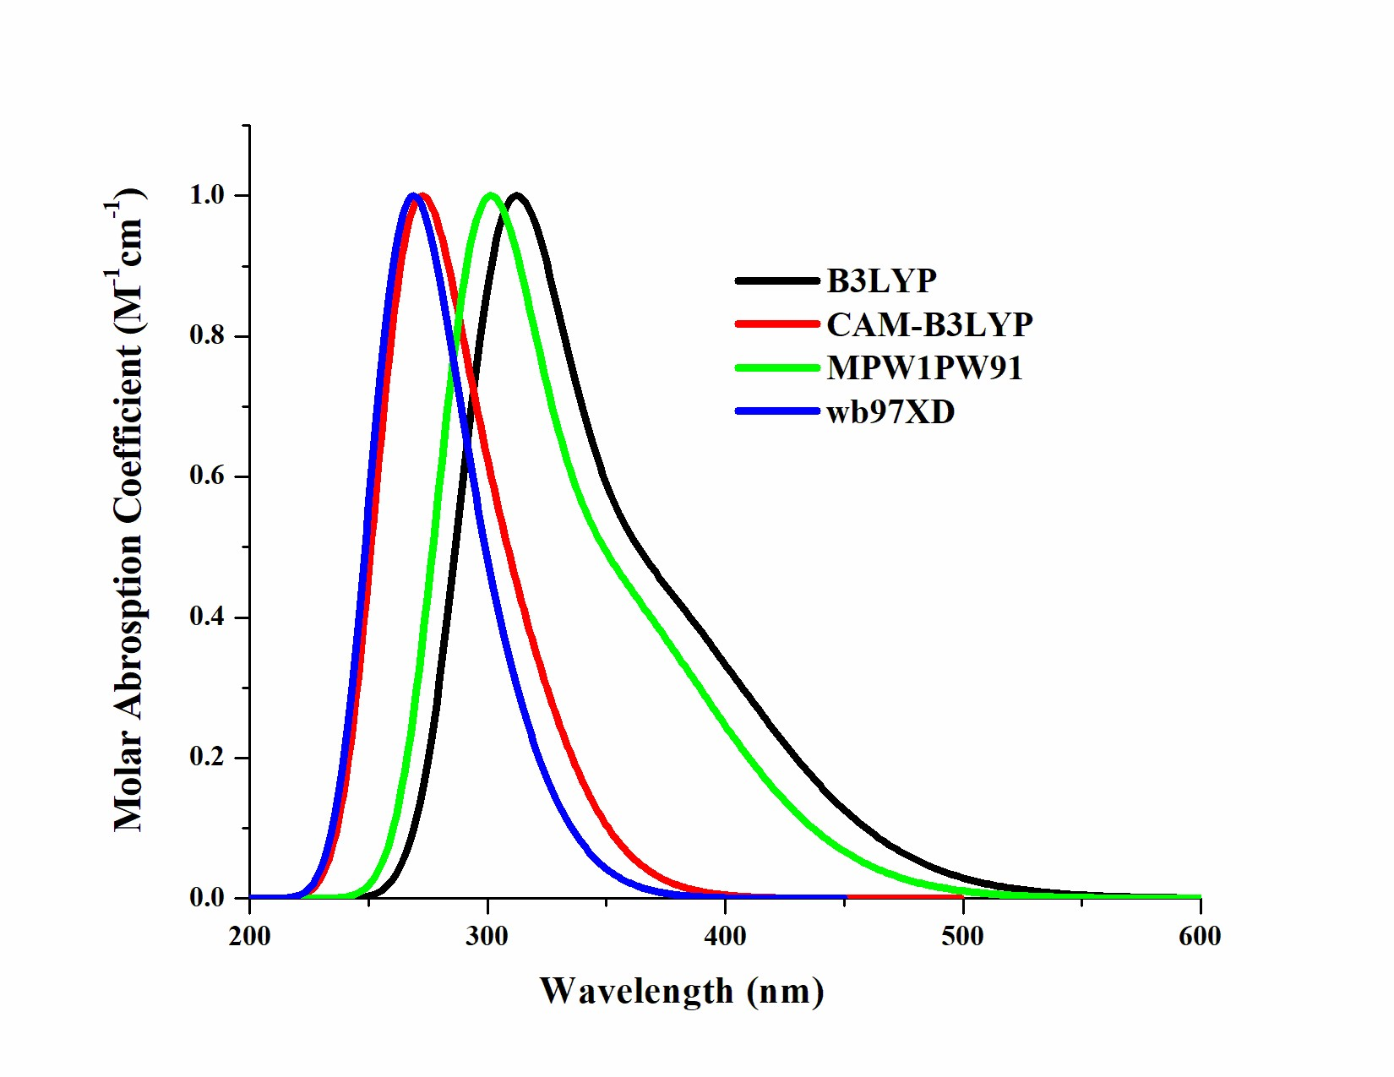
Supplementary Fig. 1. Absorption spectra of reference molecules calculated with different functional.

